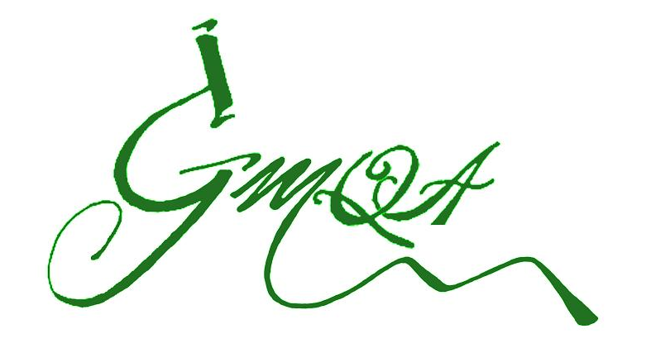
WEBINARS
11:00am-12:30pm ET
12 March 2018: Data Integrity Overview
13 March 2018: Management Culture & Governance Programs for Data Integrity
14 March 2018: Reviewing Electronic Data & Audit Trails
15 March 2018: Data Process Mapping & Data Life Cycle
16 March 2018: Data Process Mapping Case Study Examples—NEW WEBINAR
Name: ___________________________________________  Please Print FIRST / LAST  Title: _____________________________________________  Organization: ______________________________________  Mailing Address: ___________________________________  City: _________________________State / Province: ______  Zip / Postal Code: ______________Country: _____________  Telephone: ( ) __________________________________  E-mail: _____________________________________________  Webinar(s) of Choice :  - 12 March 2018, Group Size: _____  - 13 March 2018, Group Size: _____  - 14 March 2018, Group Size: _____  - 15 March 2018, Group Size: _____  - 16 March 2018, Group Size: _____ | REGISTRATION FEES  Individual Registration:  _____ $399 USD  Group of 2-4 Persons Registration:  _____ $699 USD  Group of 5-10 Persons Registration:  _____ $1625 USD  Group of >10 Persons Registration:  _____ $2500 USD  Cancellation Policy:. Full refunds of registration fees will be made with cancellations received more than 24 hours prior to the webinar's start time. Refunds are not provided for no-shows nor for cancellations received after the webinar link has been provided, however, participant substitutions are permitted if requested via info@GMQA.net prior to the webinar's start time. GMQA reserves the right to cancel webinars and is not responsible for any other costs incurred by registrants.
Registration Fees: USD $ ________  Payment Method:  ____To pay online payment with Credit Card or PayPal visit www.GMQATraining.com .  ___ Payment by Check in US Dollars: please send by mail to GMQA offices address listed to the right.  ___ Offline Credit Card Payment  Card #: __________________________________________  CSC # (security code): _________ Exp (mm/yy): ______  Card Holder Information: (Billing Address)  First name: _____________Last name:_________________  Address: __________________________________________  City: ________________________Province / State: _______  Postal Code: ______________Country:__________________  Telephone number: ___________________________  Email: __________________________________________  Signature:_________________________________________ | Questions?  Contact: Monica Cahilly  Green Mtn Quality Assurance, LLC  1497 Golf Course Rd  Warren, VT 05674 USA  (O) +1-802-496-5810  (F) +1-802-496-4217  email: info@GMQA.net  Fax to +1 802 496 4217 or mail completed forms with payment to GMQA address above or scan and email to info@GMQA.net

